Ph 211 -- Exam 2 – 8am Version Solutions Fall 2016

This is a 55 minute exam. As always, make sure that you show all of your work for full credit and to maximize partial credit. Scratch paper may be used. No notes are allowed. Only a “simple” calculator may be used. Remember not to talk to anyone about the exam until after noon today.

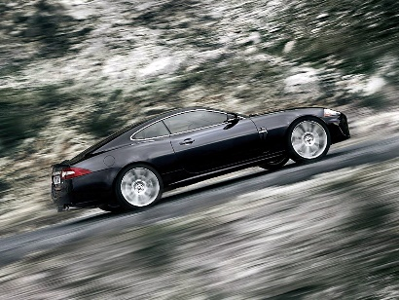
1. (2½ points) This car is slowing down as it is traveling up a hill. Draw a free body diagram (FBD) for the car at this instant.

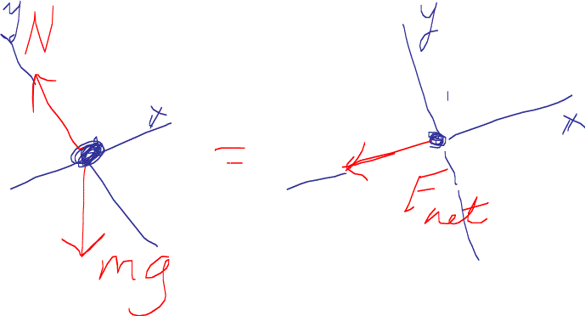
Other forces such as Drag, Static Friction pointing upward, or Rolling Friction pointing downward could have been included. But, only N, mg and a downhill pointing Fnet need to be included to correctly answer this question.

2. (2½ points) This text book is slipping out of Tak’s grip at constant speed. Draw a FBD for the book at this instant.

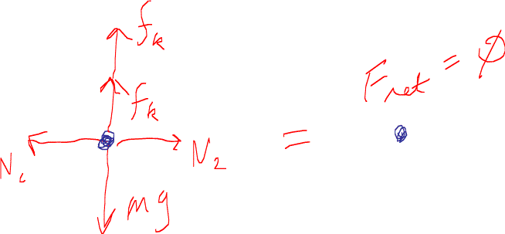

It must be made clear that it is understood that F_{net}=0 N. One way to do this is write Fnet=0. Another way to do this is to write something like |N₁| = |N₂| and |f_{k1} + f_{k2}| = |mg|.


3. (2½ points) This cat has just jumped up from the ground. The cat is still moving upward at the instant this picture was taken. Draw a FBD for the cat at this instant.

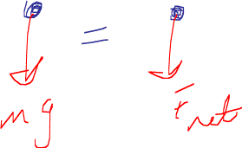

4. (2½ points) Jay and Cindy are playing tug-o-war. Cindy is pulling with a force of 200 N. Jay is simply hanging on, but skidding towards Cindy at a constant velocity. What is the force of friction between Jay's feet and the ground?
Less than 200 N Greater than 200 N, but less than 400 N 400 N X 200 N

10

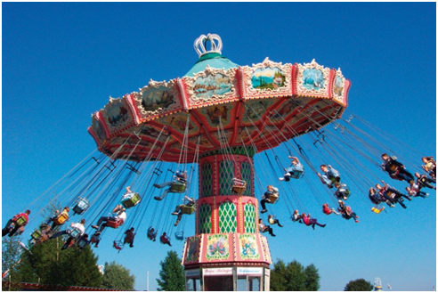
5. (2 points) Draw a free body diagram for the person circled in left-hand side of the picture.

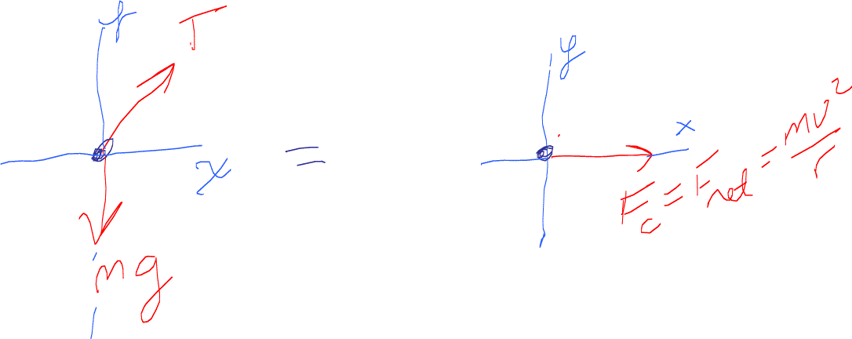


6. (2 points) This flatbed truck carrying an elephant is driving forward. The driver slams on the breaks. Fortunately for the elephant the coefficient of friction between her feet and the bed of the truck is very large and she does not slip. Draw a free-body diagram for the elephant during the breaking process.

In this problem we should note that the acceleration of the truck and of the elephant points to the right.
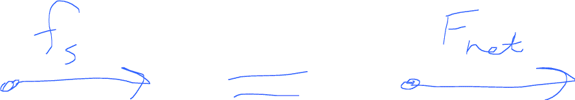

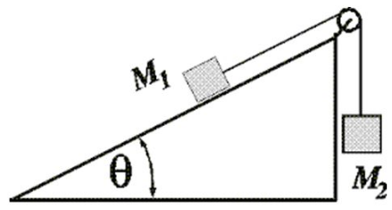
7. (4 points) M₁ is speeding up as it slides up the ramp. Draw a FBD for M₁ and draw a FBD for M₂.
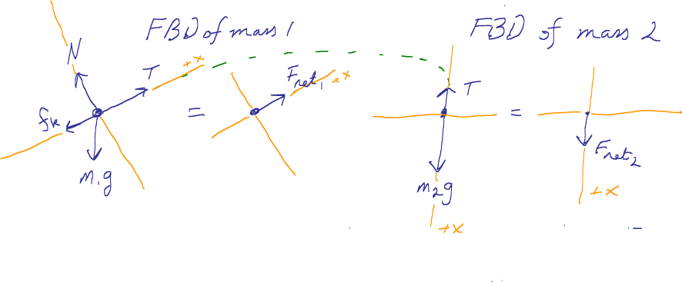

Some general things to make sure that you have right in such FBDs:
- Make sure that you have your axes correctly defined – in this case, note the position of the positive-x axis in both FBDs.
- It is always useful to clearly note action reaction pairs as I did here with the green dotted line.
8. (2 points) Draw a velocity vs. time and an acceleration vs. time graph for a person who jumped out a helicopter hovering at a high height.
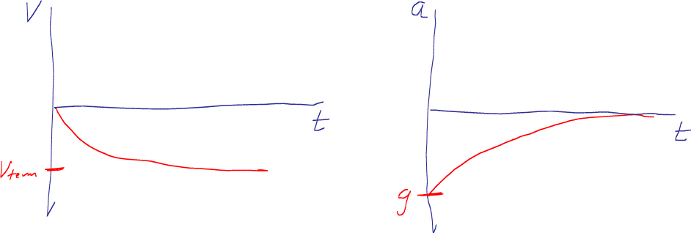

10

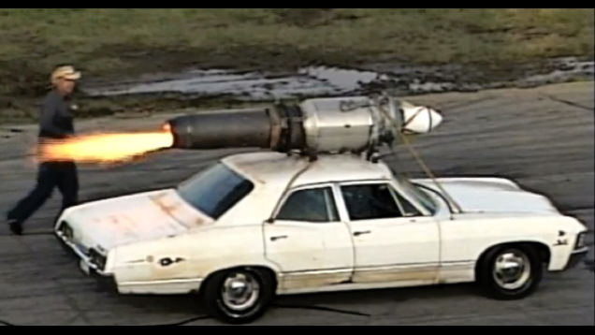
9 (10 points) Paul Stender’s car has a rocket attached to it. While on, the rocket provides a thrust force of 51,500 Newtons. The car has as mass of 3,222kg. The coefficients of friction with the road and the tires are μ_{k}=.321, μ_{s}=.432, μ_{r}=.111, and the coefficient of drag is 0.800. The car is 3.0 meters long, 2.0 meters wide and 1.5 meters tall. The density of air is ρ=1.3kg/m³.
Remember that the equation for the force of drag is: D = ½ρAC_{d}v².

Sketch out below a VPython program that will calculate the position, velocity and acceleration every tenth of a second for 5 seconds. As always, make sure that you show all your work in order to maximize your partial credit.

Note that it is more important for you demonstrate that you know how to solve a motion problem iteratively and the physics behind the problem than you know exactly where to put semicolons and exact python syntax.

from visual import *
m = 3222 #kg
v = vector(0,0,0)
s = vector(0,0,0)
g = 9.8
Fth = vector(51500,0,0) #N
muk = .321; mus = .432; mur = .111
Cd = 0.8
L = 3.0; W = 2.0; H = 1.5 #m
rhoair = 1.3 # kg/m^3
N = m*g
t = 0.0
dt = .1
while t < 5.0:
Drag = 0.5*rhoair*W*H*Cd*mag(v)**2*norm(-v)
Frollingfriction = mur*N*vector(-1,0,0)
Fnet = Fth + Drag - Frollingfriction
a = Fnet/m
v = v + a*dt
s = s + v*dt
t = t + dt
print t, s, v, a

10. (10 points) The device shown here is a record player. The black disc shown is called a record and spins around a pin in the center. An eraser of m=125g is placed a distance r=10.0cm from the center of the record. The record player is turned on and the record speeds up. When the record gets to a rotational period of τ=0.40 seconds, the eraser slides off the record.

What is the coefficient of friction between the eraser and the record? You may provide either a numeric or symbolic solution.

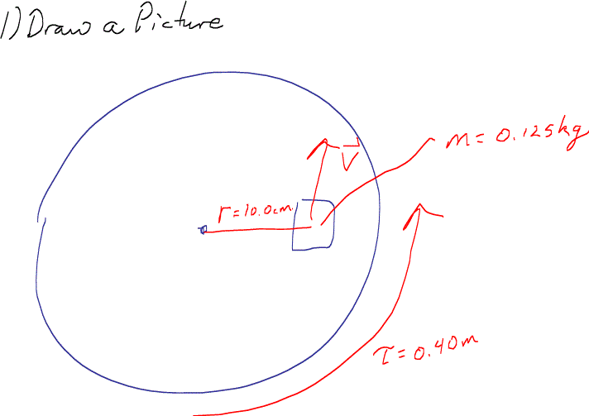

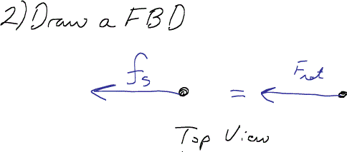

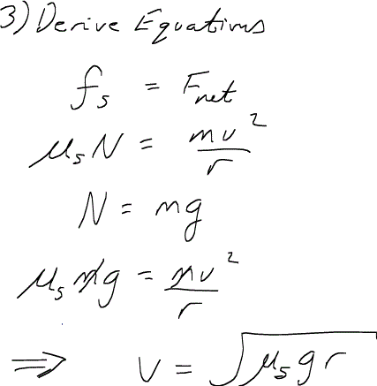
10
11. (10 points) Block A, with a mass of m_{A}, slides down an inclined plane with an angle of θ at a constant speed. Plank B rests on top of A and has a mass of m_{B}. The plank is attached by a cord to the top of the plane. The plane, the plank and mass are all made out of the same material thus the coefficient of friction is the same at all surfaces. Determine the coefficient of kinetic friction in this problem. State your solution in terms of m_{A}, m_{B}, θ, and any other relevant physical constants.
m_{B}
m_{A}

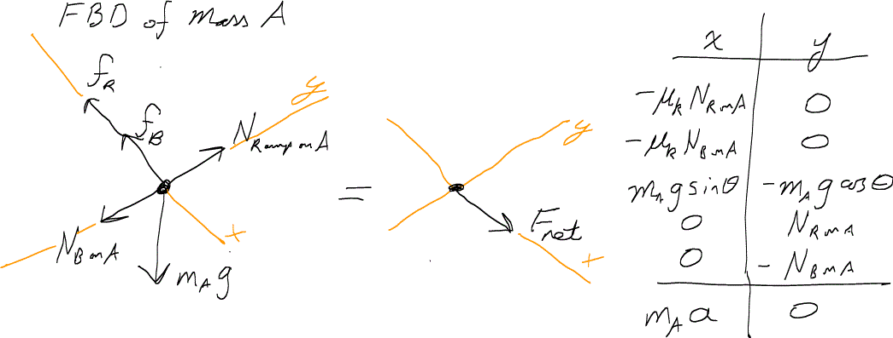

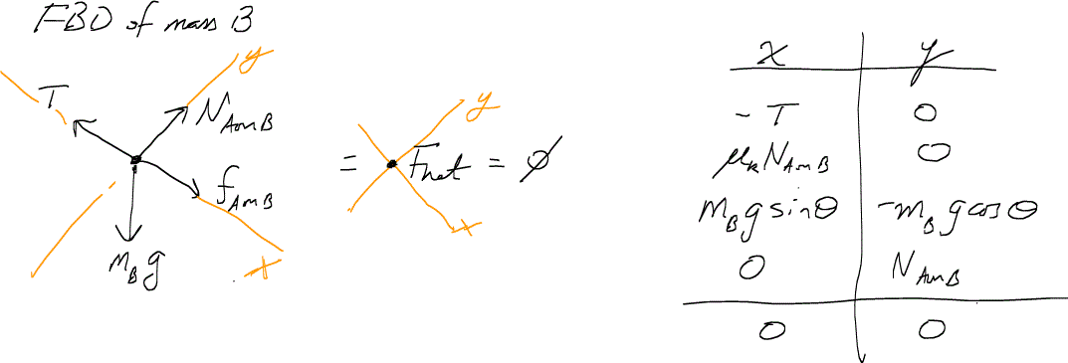

Turning the FBDs into equations we find:
(1) -μ_{k}N_{RonA} - μ_{k}N_{BonA} + m_{A}gsinθ = m_{A}a_{A}
(2) -m_{A}gcosθ + N_{RonA} – N_{BonA} = 0
(3) -T + μ_{k}N_{AonB} + m_{B}gsinθ = 0
(4) -m_{B}gcosθ + N_{AonB} = 0

Our goal is to find μ_{k}.
Realizing that there are a couple of action/reaction pairs here and that m_{A} is slipping at constant velocity we can:
- solve (2) for N_{RonA} and plug that into (1);
- then we can solve (3) for NBonA and plug that into (1);
- and then set a = 0.
What we find is:

μ_{k} = ( m_{A}gsinθ ) / ( N_{RonA} + N_{BonA} )

μ_{k} = ( m_{A}gsinθ ) / (+m_{A}gcosθ + N_{BonA} + N_{BonA})

μ_{k} = ( m_{A}gsinθ ) / (+m_{A}gcosθ + 2(m_{B}gcosθ) )

10

Extra Credit:
In this image, we see Garrett firing a laser beam. He measures the speed of the light coming out of the laser to be 3.0·10⁸m/s. Taylor happens to be flying overhead in a rocket ship going by at 2.0·10⁸m/s. At what speed would Taylor see the laser be go by her window if:

a) …the universe always behaved under Galilean transformation.

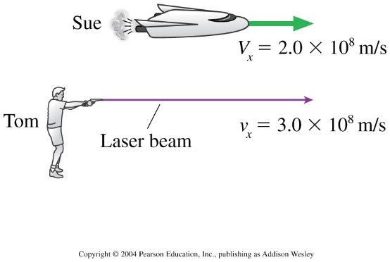
b) … we were to actually perform this experiment with the knowledge we gained about 110 years ago about our universe.
Garrett
Taylor

4
10

